

Introduction

This Project has been designed for the final group project in E-soft Institute. This project was build by using C#.NET 2015 The Name of the project is “**Bright Education Acadamy in Sri Lanka**” and it’s about a Student Registration System. Our Target was to do our best for this project and present a good thing. We had to work hard to success this project. We met some problems when we designing this System and our teachers helped us to solve those problems and to coninue the project. We used the programs like Photoshop CC , MS Word 2010 which we learnt from the class lessons to make our project better. Finally we thank to the techers in E-soft that helped us a lot to do our project. We hope you will like this project.

Our Group Members :-

1) D.d.s.Rajapakshe ( B1804 )

2) Isuri Kaushali ( B2060 )

3) Palihawadanage asha ( B2080 )

4) K. Hasani Madushika (B2064)

5) Dinule. Tilaka ( B2093 )

Batch …38

Menu …

1. Loading page
2. Chooser Menu page
3. Administrator Login page
4. User Login page
5. Administrator Main Menu page
6. User Main Menu page
7. Main Menu page
8. Student Detail page
9. Reenter password page
10. View Personal page
11. View Education page
12. View Payment page
13. View Qualifications page
14. Cashier Receipt page
15. Education Details page
16. Student Register page
17. Personal Details Page
18. Qualifications Details page
19. About
20. Software Program page
21. Degree Program page
22. UGC Programs
23. Curtin University Programs
24. Help
25. Student Registration System USE Case
26. Loading page



using System;

using System.Collections.Generic;

using System.ComponentModel;

using System.Data;

using System.Drawing;

using System.Linq;

using System.Text;

using System.Threading.Tasks;

using System.Windows.Forms;

using WMPLib;

namespace Bright_Education_Acadamy_in_Sri_Lanka

{

public partial class Loading : Form

{

WindowsMediaPlayer player = new WindowsMediaPlayer();

bool flag;

public Loading()

{

InitializeComponent();

player.URL = "harry_potter_7.mp3";

}

private void Form1_Load(object sender, EventArgs e)

{

{

flag = true;

timer1.Enabled = true;

player.controls.play();

}

}

private void timer1_Tick(object sender, EventArgs e)

{

{

if (progressBar1.Value < 99)

{

if (flag)

{

flag = false;

lblLoading.Text = "Loading..";

}

else

{

flag = true;

lblLoading.Text = "Loading...";

}

progressBar1.Value += 10;

if (progressBar1.Value > 90)

{

timer2.Enabled = true;

timer2.Start();

}

}

else

{

timer1.Stop();

timer1.Enabled = false;

}

}

}

private void timer2_Tick(object sender, EventArgs e)

{

this.Opacity -= 0.025;

if (this.Opacity <= 0)

{

timer2.Enabled = false;

this.Visible = false;

new Chooser_Menu().Show();

}

}

private void progressBar1_Click(object sender, EventArgs e)

{

}

}

}

02. Chooser Menu page

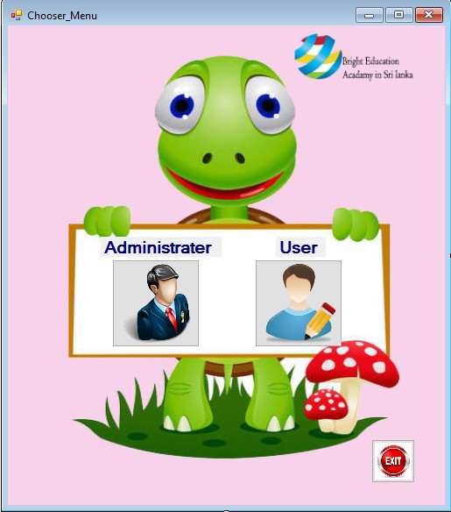

using System;

using System.Collections.Generic;

using System.ComponentModel;

using System.Data;

using System.Drawing;

using System.Linq;

using System.Text;

using System.Threading.Tasks;

using System.Windows.Forms;

namespace Bright_Education_Acadamy_in_Sri_Lanka

{

public partial class Chooser_Menu : Form

{

public Chooser_Menu()

{

InitializeComponent();

}

private void btnAd_Click(object sender, EventArgs e)

{

timer1.Enabled = true;

timer1.Start();

}

private void timer1_Tick(object sender, EventArgs e)

{

this.Opacity -= 0.10;

if (this.Opacity <= 0)

{

this.Visible = false;

timer1.Enabled = false;

new Administrator_Login().Show();

}

}

private void timer2_Tick(object sender, EventArgs e)

{

this.Opacity -= 0.10;

if (this.Opacity <= 0)

{

this.Visible = false;

timer2.Enabled = false;

new User_Loging().Show();

}

}

private void btnUs_Click(object sender, EventArgs e)

{

timer2.Enabled = true;

timer2.Start();

}

private void btnExit_Click(object sender, EventArgs e)

{

DialogResult Dialog = MessageBox.Show(" Do you really want to Exit From The program ?", "Exit", MessageBoxButtons.YesNo);

if (Dialog == DialogResult.Yes)

{

Application.Exit();

}

else if (Dialog == DialogResult.No)

{

}

}

}

}

03. Administrator Login page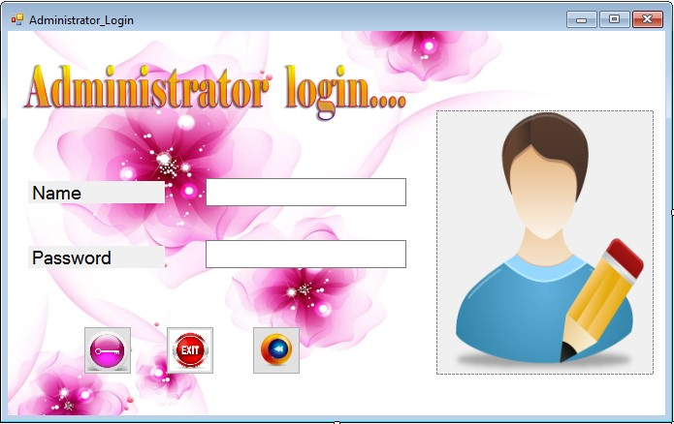

using System;

using System.Collections.Generic;

using System.ComponentModel;

using System.Data;

using System.Drawing;

using System.Linq;

using System.Text;

using System.Threading.Tasks;

using System.Windows.Forms;

namespace Bright_Education_Acadamy_in_Sri_Lanka

{

public partial class Administrator_Login : Form

{

public Administrator_Login()

{

InitializeComponent();

}

private void btnLo_Click(object sender, EventArgs e)

{

String Na = "Bright";

String Pa = "12345";

{

{

if (txtNa.Text == Na && txtPa.Text == Pa)

{

timer2.Enabled = true;

timer2.Start();

}

else

{

MessageBox.Show(" Wrong Username or Password ! ");

txtNa.Clear();

txtPa.Clear();

txtNa.Focus();

}

}

}

}

private void btnE_Click(object sender, EventArgs e)

{

DialogResult Dialog = MessageBox.Show(" Do you really want to Exit

From The program ?", "Exit", MessageBoxButtons.YesNo);

if (Dialog == DialogResult.Yes)

{

Application.Exit();

}

else if (Dialog == DialogResult.No)

{

}

}

private void btnb_Click(object sender, EventArgs e)

{

timer1.Enabled = true;

timer1.Start();

}

private void timer1_Tick(object sender, EventArgs e)

{

this.Opacity -= 0.10;

if (this.Opacity <= 0)

{

this.Visible = false;

timer1.Enabled = false;

new Chooser_Menu().Show();

}

}

private void timer2_Tick(object sender, EventArgs e)

{

this.Opacity -= 0.10;

if (this.Opacity <= 0)

{

this.Visible = false;

timer2.Enabled = false;

new Administrator_Main_Menu().Show();

}

}

}

}

04. User Login page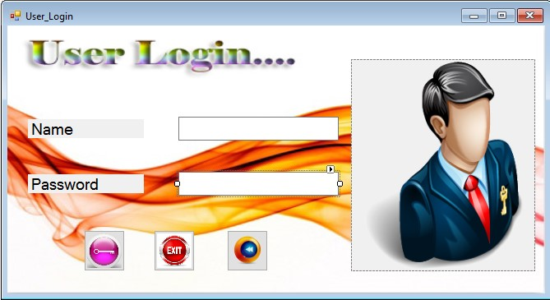

using System;

using System.Collections.Generic;

using System.ComponentModel;

using System.Data;

using System.Drawing;

using System.Linq;

using System.Text;

using System.Threading.Tasks;

using System.Windows.Forms;

namespace Bright_Education_Acadamy_in_Sri_Lanka

{

public partial class User_Loging : Form

{

public User_Loging()

{

InitializeComponent();

}

private void btnLo_Click(object sender, EventArgs e)

{

String Na = "Bright";

String Pa = "1234";

{

{

if (txtNa.Text == Na && txtPa.Text == Pa)

{

timer2.Enabled = true;

timer2.Start();

}

else

{

MessageBox.Show(" Wrong Username or Password ! ");

txtNa.Clear();

txtPa.Clear();

txtNa.Focus();

}

}

}

}

private void btnE_Click(object sender, EventArgs e)

{

DialogResult Dialog = MessageBox.Show(" Do you really want to Exit From The program ?", "Exit", MessageBoxButtons.YesNo);

if (Dialog == DialogResult.Yes)

{

Application.Exit();

}

else if (Dialog == DialogResult.No)

{

}

}

private void btnb_Click(object sender, EventArgs e)

{

timer1.Enabled = true;

timer1.Start();

}

private void timer1_Tick(object sender, EventArgs e)

{

this.Opacity -= 0.10;

if (this.Opacity <= 0)

{

this.Visible = false;

timer1.Enabled = false;

new Chooser_Menu().Show();

}

}

private void timer2_Tick(object sender, EventArgs e)

{

this.Opacity -= 0.10;

if (this.Opacity <= 0)

{

this.Visible = false;

timer2.Enabled = false;

new User_Main_Menu().Show();

}

}

}

}

05. Administrator Main Menu page

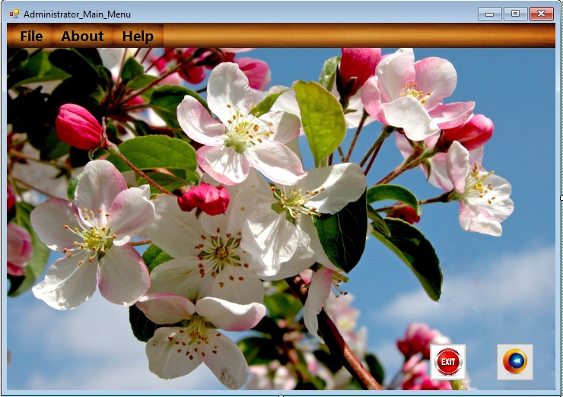

using System;

using System.Collections.Generic;

using System.ComponentModel;

using System.Data;

using System.Drawing;

using System.Linq;

using System.Text;

using System.Threading.Tasks;

using System.Windows.Forms;

namespace Bright_Education_Acadamy_in_Sri_Lanka

{

public partial class Administrator_Main_Menu : Form

{

public Administrator_Main_Menu()

{

InitializeComponent();

}

private void cashierReceiptToolStripMenuItem_Click(object sender, EventArgs e)

{

timer1.Enabled = true;

timer1.Start();

}

private void educationDetailsToolStripMenuItem_Click(object sender, EventArgs e)

{

timer3.Enabled = true;

timer3.Start();

}

private void studentDetailsToolStripMenuItem1_Click(object sender, EventArgs e)

{

timer4.Enabled = true;

timer4.Start();

}

private void aboutToolStripMenuItem_Click(object sender, EventArgs e)

{

timer5.Enabled = true;

timer5.Start();

}

private void helpToolStripMenuItem_Click(object sender, EventArgs e)

{

timer6.Enabled = true;

timer6.Start();

}

private void timer1_Tick(object sender, EventArgs e)

{

this.Opacity -= 0.10;

if (this.Opacity <= 0)

{

this.Visible = false;

timer1.Enabled = false;

new Cashier_Receipt().Show();

}

}

private void timer2_Tick(object sender, EventArgs e)

{

this.Opacity -= 0.10;

if (this.Opacity <= 0)

{

this.Visible = false;

timer2.Enabled = false;

new Student_Register().Show();

}

}

private void timer3_Tick(object sender, EventArgs e)

{

this.Opacity -= 0.10;

if (this.Opacity <= 0)

{

this.Visible = false;

timer3.Enabled = false;

new Education_Details().Show();

}

}

private void timer4_Tick(object sender, EventArgs e)

{

this.Opacity -= 0.10;

if (this.Opacity <= 0)

{

this.Visible = false;

timer4.Enabled = false;

new Reenter_Password().Show();

}

}

private void timer5_Tick(object sender, EventArgs e)

{

this.Opacity -= 0.10;

if (this.Opacity <= 0)

{

this.Visible = false;

timer5.Enabled = false;

new About().Show();

}

}

private void timer6_Tick(object sender, EventArgs e)

{

this.Opacity -= 0.10;

if (this.Opacity <= 0)

{

this.Visible = false;

timer6.Enabled = false;

new Help().Show();

}

}

private void timer7_Tick(object sender, EventArgs e)

{

this.Opacity -= 0.10;

if (this.Opacity <= 0)

{

this.Visible = false;

timer7.Enabled = false;

new Chooser_Menu().Show();

}

}

private void btnE_Click(object sender, EventArgs e)

{

DialogResult Dialog = MessageBox.Show(" Do you really want to Exit From The program ?", "Exit", MessageBoxButtons.YesNo);

if (Dialog == DialogResult.Yes)

{

Application.Exit();

}

else if (Dialog == DialogResult.No)

{

}

}

private void btnb_Click(object sender, EventArgs e)

{

timer7.Enabled = true;

timer7.Start();

}

private void studentDetailsToolStripMenuItem_Click(object sender, EventArgs e)

{

timer2.Enabled = true;

timer2.Start();

}

}

}

06. User Main Menu page

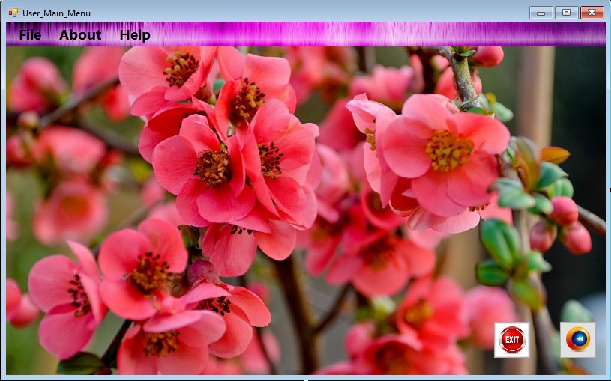

using System;

using System.Collections.Generic;

using System.ComponentModel;

using System.Data;

using System.Drawing;

using System.Linq;

using System.Text;

using System.Threading.Tasks;

using System.Windows.Forms;

namespace Bright_Education_Acadamy_in_Sri_Lanka

{

public partial class User_Main_Menu : Form

{

public User_Main_Menu()

{

InitializeComponent();

}

private void cashierReceiptToolStripMenuItem_Click(object sender, EventArgs e)

{

timer1.Enabled = true;

timer1.Start();

}

private void educationDetailsToolStripMenuItem_Click(object sender, EventArgs e)

{

timer3.Enabled = true;

timer3.Start();

}

private void aboutToolStripMenuItem_Click(object sender, EventArgs e)

{

timer4.Enabled = true;

timer4.Start();

}

private void helpToolStripMenuItem_Click(object sender, EventArgs e)

{

timer5.Enabled = true;

timer5.Start();

}

private void btnE_Click(object sender, EventArgs e)

{

DialogResult Dialog = MessageBox.Show(" Do you really want to Exit From The program ?", "Exit", MessageBoxButtons.YesNo);

if (Dialog == DialogResult.Yes)

{

Application.Exit();

}

else if (Dialog == DialogResult.No)

{

}

}

private void btnb_Click(object sender, EventArgs e)

{

timer6.Enabled = true;

timer6.Start();

}

private void timer1_Tick(object sender, EventArgs e)

{

this.Opacity -= 0.10;

if (this.Opacity <= 0)

{

this.Visible = false;

timer1.Enabled = false;

new Cashier_Receipt().Show();

}

}

private void timer2_Tick(object sender, EventArgs e)

{

this.Opacity -= 0.10;

if (this.Opacity <= 0)

{

this.Visible = false;

timer2.Enabled = false;

new Student_Register().Show();

}

}

private void timer3_Tick(object sender, EventArgs e)

{

this.Opacity -= 0.10;

if (this.Opacity <= 0)

{

this.Visible = false;

timer3.Enabled = false;

new Education_Details().Show();

}

private void timer4_Tick(object sender, EventArgs e)

{

this.Opacity -= 0.10;

if (this.Opacity <= 0)

{

this.Visible = false;

timer4.Enabled = false;

new About().Show();

}

}

private void timer5_Tick(object sender, EventArgs e)

{

this.Opacity -= 0.10;

if (this.Opacity <= 0)

{

this.Visible = false;

timer5.Enabled = false;

new Help().Show();

}

}

private void timer6_Tick(object sender, EventArgs e)

{

this.Opacity -= 0.10;

if (this.Opacity <= 0)

{

this.Visible = false;

timer6.Enabled = false;

new Chooser_Menu().Show();

}

}

private void studentRegisterToolStripMenuItem_Click(object sender, EventArgs e)

{

timer2.Enabled = true;

timer2.Start();

}

private void studenntDetailsToolStripMenuItem_Click(object sender, EventArgs e)

{

timer7.Enabled = true;

timer7.Start();

}

private void timer7_Tick(object sender, EventArgs e)

{

this.Opacity -= 0.10;

if (this.Opacity <= 0)

{

this.Visible = false;

timer7.Enabled = false;

new Administrator_Login().Show();

}

}

}

}

07.Main Menu page

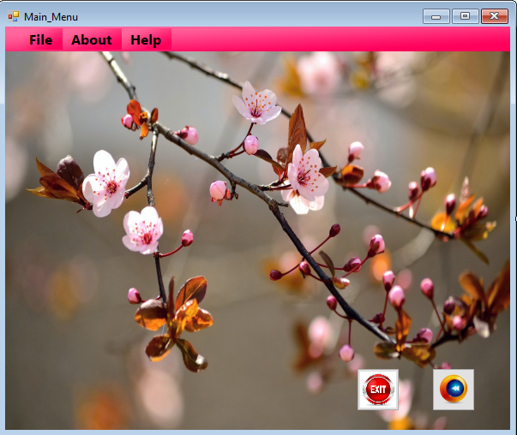

using System;

using System.Collections.Generic;

using System.ComponentModel;

using System.Data;

using System.Drawing;

using System.Linq;

using System.Text;

using System.Threading.Tasks;

using System.Windows.Forms;

namespace Bright_Education_Acadamy_in_Sri_Lanka

{

public partial class Main_Menu : Form

{

public Main_Menu()

{

InitializeComponent();

}

private void cashierReceiptToolStripMenuItem_Click(object sender, EventArgs e)

{

timer1.Enabled = true;

timer1.Start();

}

private void educationDetailsToolStripMenuItem_Click(object sender, EventArgs e)

{

timer2.Enabled = true;

timer2.Start();

}

private void studentDetailsToolStripMenuItem1_Click(object sender, EventArgs e)

{

timer3.Enabled = true;

timer3.Start();

}

private void aboutToolStripMenuItem_Click(object sender, EventArgs e)

{

timer4.Enabled = true;

timer4.Start();

}

private void helpToolStripMenuItem_Click(object sender, EventArgs e)

{

timer5.Enabled = true;

timer5.Start();

}

private void btnE_Click(object sender, EventArgs e)

{

DialogResult Dialog = MessageBox.Show(" Do you really want to Exit From The program ?", "Exit", MessageBoxButtons.YesNo);

if (Dialog == DialogResult.Yes)

{

Application.Exit();

}

else if (Dialog == DialogResult.No)

{

}

}

private void btnb_Click(object sender, EventArgs e)

{

timer7.Enabled = true;

timer7.Start();

}

private void timer1_Tick(object sender, EventArgs e)

{

this.Opacity -= 0.10;

if (this.Opacity <= 0)

{

this.Visible = false;

timer1.Enabled = false;

new Cashier_Receipt().Show();

}

}

private void timer2_Tick(object sender, EventArgs e)

{

this.Opacity -= 0.10;

if (this.Opacity <= 0)

{

this.Visible = false;

timer2.Enabled = false;

new Education_Details().Show();

}

}

private void timer3_Tick(object sender, EventArgs e)

{

this.Opacity -= 0.10;

if (this.Opacity <= 0)

{

this.Visible = false;

timer3.Enabled = false;

new Reenter_Password().Show();

}

}

private void timer4_Tick(object sender, EventArgs e)

{

this.Opacity -= 0.10;

if (this.Opacity <= 0)

{

this.Visible = false;

timer4.Enabled = false;

new About().Show();

}

}

private void timer5_Tick(object sender, EventArgs e)

{

this.Opacity -= 0.10;

if (this.Opacity <= 0)

{

this.Visible = false;

timer5.Enabled = false;

new Help().Show();

}

}

private void timer6_Tick(object sender, EventArgs e)

{

this.Opacity -= 0.10;

if (this.Opacity <= 0)

{

this.Visible = false;

timer6.Enabled = false;

new Student_Register().Show();

}

}

private void timer7_Tick(object sender, EventArgs e)

{

this.Opacity -= 0.10;

if (this.Opacity <= 0)

{

this.Visible = false;

timer7.Enabled = false;

new Chooser_Menu().Show();

}

}

private void studentRegisterToolStripMenuItem_Click(object sender, EventArgs e)

{

timer6.Enabled = true;

timer6.Start();

}

}

}

08.Student Detail page

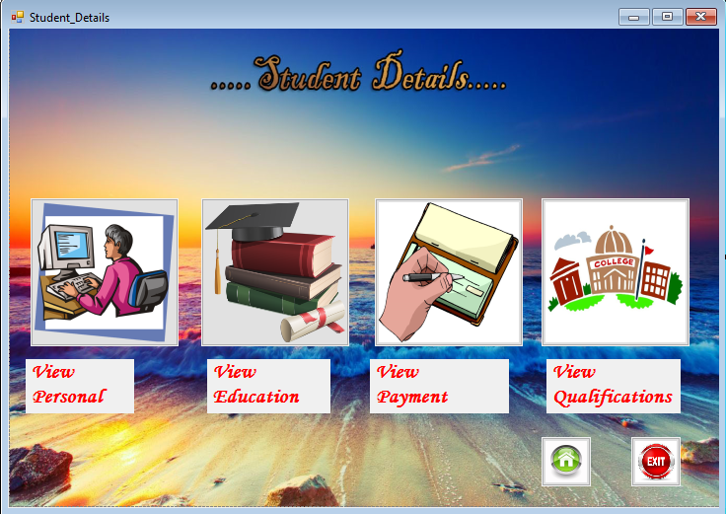

using System;

using System.Collections.Generic;

using System.ComponentModel;

using System.Data;

using System.Drawing;

using System.Linq;

using System.Text;

using System.Threading.Tasks;

using System.Windows.Forms;

namespace Bright_Education_Acadamy_in_Sri_Lanka

{

public partial class Student_Details : Form

{

public Student_Details()

{

InitializeComponent();

}

private void timer1_Tick(object sender, EventArgs e)

{

this.Opacity -= 0.10;

if (this.Opacity <= 0)

{

this.Visible = false;

timer1.Enabled = false;

new View_Personal().Show();

}

}

private void timer2_Tick(object sender, EventArgs e)

{

this.Opacity -= 0.10;

if (this.Opacity <= 0)

{

this.Visible = false;

timer2.Enabled = false;

new View_Education().Show();

}

}

private void timer3_Tick(object sender, EventArgs e)

{

this.Opacity -= 0.10;

if (this.Opacity <= 0)

{

this.Visible = false;

timer3.Enabled = false;

new View_Payment().Show();

}

}

private void timer4_Tick(object sender, EventArgs e)

{

this.Opacity -= 0.10;

if (this.Opacity <= 0)

{

this.Visible = false;

timer4.Enabled = false;

new View_Qualifications().Show();

}

}

private void btnPe_Click(object sender, EventArgs e)

{

timer1.Enabled = true;

timer1.Start();

}

private void btnEd_Click(object sender, EventArgs e)

{

timer2.Enabled = true;

timer2.Start();

}

private void btnExit_Click(object sender, EventArgs e)

{

DialogResult Dialog = MessageBox.Show(" Do you really want to Exit From The program ?", "Exit", MessageBoxButtons.YesNo);

if (Dialog == DialogResult.Yes)

{

Application.Exit();

}

else if (Dialog == DialogResult.No)

{

}

}

private void Student_Details_Load(object sender, EventArgs e)

{

this.MaximumSize = this.MinimumSize = this.Size;

this.MaximizeBox = false;

}

private void btnMain_Menu_Click(object sender, EventArgs e)

{

timer5.Enabled = true;

timer5.Start();

}

private void timer5_Tick(object sender, EventArgs e)

{

this.Opacity -= 0.10;

if (this.Opacity <= 0)

{

this.Visible = false;

timer5.Enabled = false;

new Administrator_Main_Menu().Show();

}

}

private void btnPa_Click_1(object sender, EventArgs e)

{

timer3.Enabled = true;

timer3.Start();

}

private void btnQu_Click_1(object sender, EventArgs e)

{

timer4.Enabled = true;

timer4.Start();

}

}

}

09. Reenter password page

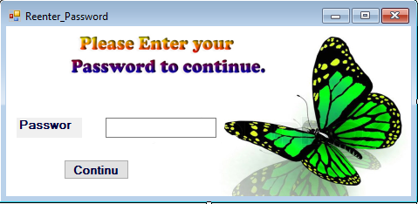

using System;

using System.Collections.Generic;

using System.ComponentModel;

using System.Data;

using System.Drawing;

using System.Linq;

using System.Text;

using System.Threading.Tasks;

using System.Windows.Forms;

namespace Bright_Education_Acadamy_in_Sri_Lanka

{

public partial class Reenter_Password : Form

{

public Reenter_Password()

{

InitializeComponent();

}

private void button1_Click(object sender, EventArgs e)

{

String Pa = "12345";

{

{

if ( txtPa.Text == Pa)

{

timer1.Enabled = true;

timer1.Start();

}

else

{

MessageBox.Show(" Wrong Username or Password ! ");

txtPa.Clear();

txtPa.Focus();

}

}

}

}

private void timer1_Tick(object sender, EventArgs e)

{

this.Opacity -= 0.10;

if (this.Opacity <= 0)

{

this.Visible = false;

timer1.Enabled = false;

new Student_Details().Show();

}

}

}

}

10. View Personal page

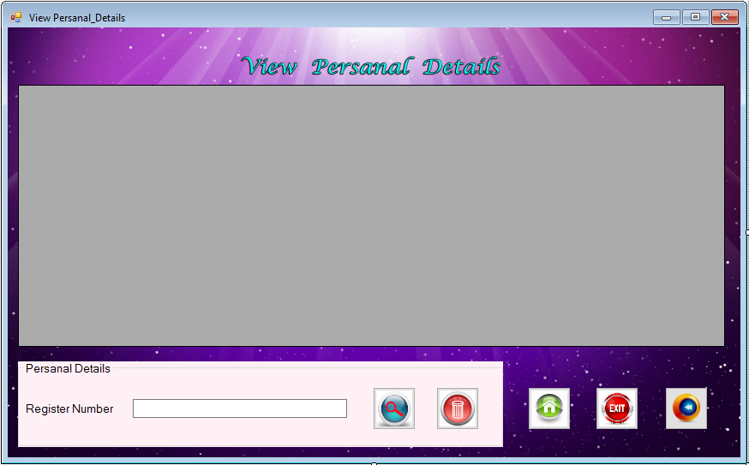

using System;

using System.Collections.Generic;

using System.ComponentModel;

using System.Data;

using System.Drawing;

using System.Linq;

using System.Text;

using System.Threading.Tasks;

using System.Windows.Forms;

using System.Data.SqlClient;

namespace Bright_Education_Acadamy_in_Sri_Lanka

{

public partial class View_Personal : Form

{

public View_Personal()

{

InitializeComponent();

}

SqlConnection con = new SqlConnection(@"Data Source = (LocalDB)\MSSQLLocalDB; AttachDbFilename=C:\Users\User\Documents\Visual Studio 2015\Projects\Bright Education Acadamy in Sri Lanka\Bright Education Acadamy in Sri Lanka\DB.mdf;Integrated Security = True");

private void btnMainmenu_Click(object sender, EventArgs e)

{

timer1.Enabled = true;

timer1.Start();

}

private void btnExit_Click(object sender, EventArgs e)

{

DialogResult Dialog = MessageBox.Show(" Do you really want to Exit From The program ?", "Exit", MessageBoxButtons.YesNo);

if (Dialog == DialogResult.Yes)

{

Application.Exit();

}

else if (Dialog == DialogResult.No)

{

}

}

private void btnback_Click(object sender, EventArgs e)

{

timer2.Enabled = true;

timer2.Start();

}

private void button1_Click(object sender, EventArgs e)

{

try

{

String Re = txtRe.Text;

string deletesql = "delete FROM Personal_Details WHERE Register_No= '" + Re + "'";

SqlCommand cmnd = new SqlCommand(deletesql, con);

con.Open();

cmnd.ExecuteNonQuery();

MessageBox.Show("Delete successfully");

}

catch (SqlException ex)

{

MessageBox.Show("Error whiling Delete" + ex);

}

finally

{

con.Close();

}

}

private void timer1_Tick(object sender, EventArgs e)

{

this.Opacity -= 0.10;

if (this.Opacity <= 0)

{

this.Visible = false;

timer1.Enabled = false;

new Main_Menu().Show();

}

}

private void timer2_Tick(object sender, EventArgs e)

{

this.Opacity -= 0.10;

if (this.Opacity <= 0)

{

this.Visible = false;

timer2.Enabled = false;

new Student_Details().Show();

}

}

private void button3_Click(object sender, EventArgs e)

{

String Re = txtRe.Text;

string query_serch = "SELECT * FROM personal_Details WHERE Register_No = '" + Re + "'";

SqlCommand cmnd = new SqlCommand(query_serch, con);

con.Open();

SqlDataAdapter da = new SqlDataAdapter("Select * from personal_Details ", con);

DataSet ds = new DataSet();

ds.Clear();

da.Fill(ds);

dataGridView1.DataSource = ds.Tables[0].DefaultView;

}

}

}

11. View Education page

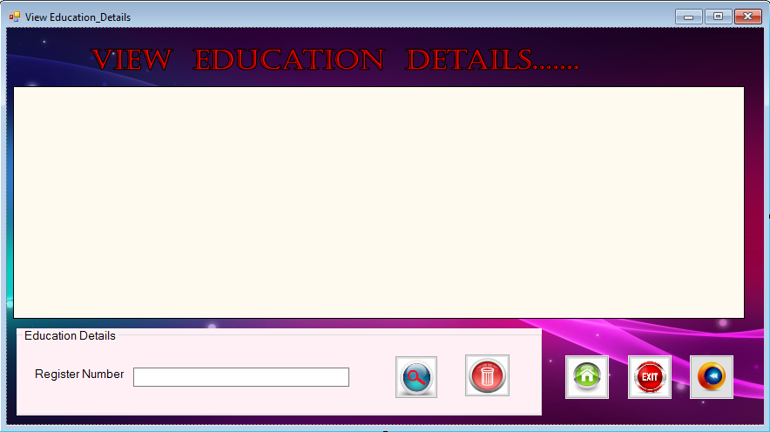

using System;

using System.Collections.Generic;

using System.ComponentModel;

using System.Data;

using System.Drawing;

using System.Linq;

using System.Text;

using System.Threading.Tasks;

using System.Windows.Forms;

using System.Data.SqlClient;

namespace Bright_Education_Acadamy_in_Sri_Lanka

{

public partial class View_Education : Form

{

public View_Education()

{

InitializeComponent();

}

SqlConnection con = new SqlConnection(@"Data Source = (LocalDB)\MSSQLLocalDB; AttachDbFilename=C:\Users\User\Documents\Visual Studio 2015\Projects\Bright Education Acadamy in Sri Lanka\Bright Education Acadamy in Sri Lanka\DB.mdf;Integrated Security = True");

private void btnMainmenu_Click(object sender, EventArgs e)

{

timer1.Enabled = true;

timer1.Start();

}

private void btnExit_Click(object sender, EventArgs e)

{

DialogResult Dialog = MessageBox.Show(" Do you really want to Exit From The program ?", "Exit", MessageBoxButtons.YesNo);

if (Dialog == DialogResult.Yes)

{

Application.Exit();

}

else if (Dialog == DialogResult.No)

{

}

}

private void btnback_Click(object sender, EventArgs e)

{

timer2.Enabled = true;

timer2.Start();

}

private void button1_Click(object sender, EventArgs e)

{

try

{

String Re = txtRe.Text;

string deletesql = "delete FROM Education_Details WHERE Register_No= '" + Re + "'";

SqlCommand cmnd = new SqlCommand(deletesql, con);

con.Open();

cmnd.ExecuteNonQuery();

MessageBox.Show("Delete successfully");

}

catch (SqlException ex)

{

MessageBox.Show("Error whiling Delete" + ex);

}

finally

{

con.Close();

}

}

private void timer1_Tick(object sender, EventArgs e)

{

this.Opacity -= 0.10;

if (this.Opacity <= 0)

{

this.Visible = false;

timer1.Enabled = false;

new Main_Menu().Show();

}

}

private void timer2_Tick(object sender, EventArgs e)

{

this.Opacity -= 0.10;

if (this.Opacity <= 0)

{

this.Visible = false;

timer2.Enabled = false;

new Student_Details().Show();

}

}

private void button3_Click(object sender, EventArgs e)

{

String Re = txtRe.Text;

string query_serch = "SELECT * FROM Education_Details WHERE Register_No = '" + Re + "'";

SqlCommand cmnd = new SqlCommand(query_serch, con);

con.Open();

SqlDataAdapter da = new SqlDataAdapter("Select * from Education_Details", con);

DataSet ds = new DataSet();

ds.Clear();

da.Fill(ds);

dataGridView1.DataSource = ds.Tables[0].DefaultView;

}

}

}

12. View Payment page

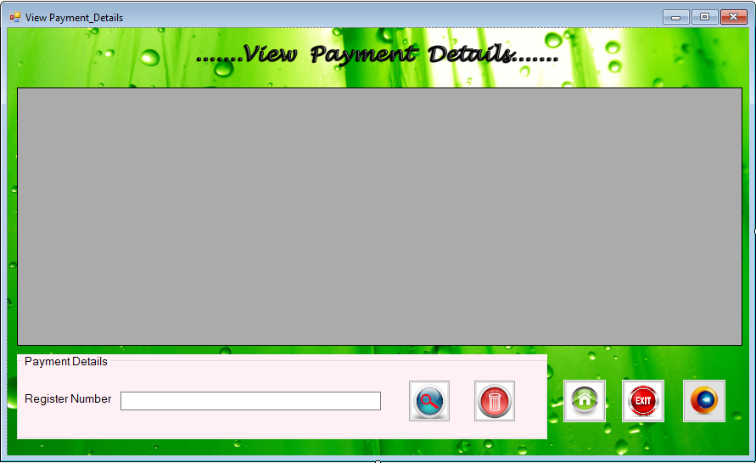

using System;

using System.Collections.Generic;

using System.ComponentModel;

using System.Data;

using System.Drawing;

using System.Linq;

using System.Text;

using System.Threading.Tasks;

using System.Windows.Forms;

using System.Data.SqlClient;

namespace Bright_Education_Acadamy_in_Sri_Lanka

{

public partial class View_Payment : Form

{

public View_Payment()

{

InitializeComponent();

}

SqlConnection con = new SqlConnection(@"Data Source = (LocalDB)\MSSQLLocalDB; AttachDbFilename=C:\Users\User\Documents\Visual Studio 2015\Projects\Bright Education Acadamy in Sri Lanka\Bright Education Acadamy in Sri Lanka\DB.mdf;Integrated Security = True");

private void btnMainmenu_Click(object sender, EventArgs e)

{

timer1.Enabled = true;

timer1.Start();

}

private void btnExit_Click(object sender, EventArgs e)

{

DialogResult Dialog = MessageBox.Show(" Do you really want to Exit From The program ?", "Exit", MessageBoxButtons.YesNo);

if (Dialog == DialogResult.Yes)

{

Application.Exit();

}

else if (Dialog == DialogResult.No)

{

}

}

private void btnback_Click(object sender, EventArgs e)

{

timer2.Enabled = true;

timer2.Start();

}

private void button1_Click(object sender, EventArgs e)

{

try

{

String Re = txtRe.Text;

string deletesql = "delete FROM Bill WHERE Register_No= '" + Re + "'";

SqlCommand cmnd = new SqlCommand(deletesql, con);

con.Open();

cmnd.ExecuteNonQuery();

MessageBox.Show("Delete successfully");

}

catch (SqlException ex)

{

MessageBox.Show("Error whiling Delete" + ex);

}

finally

{

con.Close();

}

}

private void timer1_Tick(object sender, EventArgs e)

{

this.Opacity -= 0.10;

if (this.Opacity <= 0)

{

this.Visible = false;

timer1.Enabled = false;

new Main_Menu().Show();

}

}

private void timer2_Tick(object sender, EventArgs e)

{

this.Opacity -= 0.10;

if (this.Opacity <= 0)

{

this.Visible = false;

timer2.Enabled = false;

new Student_Details().Show();

}

}

private void button3_Click(object sender, EventArgs e)

{

String Re = txtRe.Text;

string query_serch = "SELECT * FROM Bill WHERE Register_No = '" + Re + "'";

SqlCommand cmnd = new SqlCommand(query_serch, con);

con.Open();

SqlDataAdapter da = new SqlDataAdapter("Select * from Bill ", con);

DataSet ds = new DataSet();

ds.Clear();

da.Fill(ds);

dataGridView1.DataSource = ds.Tables[0].DefaultView;

}

}

}

13. View Qualifications page

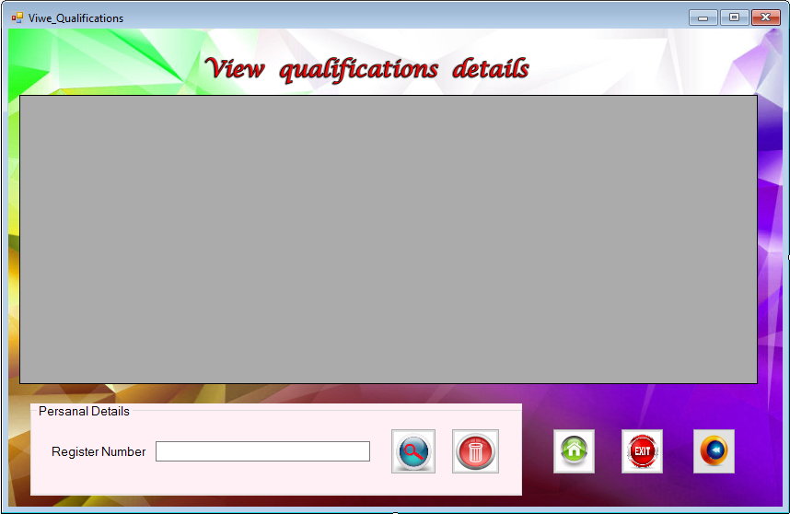

using System;

using System.Collections.Generic;

using System.ComponentModel;

using System.Data;

using System.Drawing;

using System.Linq;

using System.Text;

using System.Threading.Tasks;

using System.Windows.Forms;

using System.Data.SqlClient;

namespace Bright_Education_Acadamy_in_Sri_Lanka

{

public partial class View_Qualifications : Form

{

public View_Qualifications()

{

InitializeComponent();

}

SqlConnection con = new SqlConnection(@"Data Source = (LocalDB)\MSSQLLocalDB; AttachDbFilename=C:\Users\User\Documents\Visual Studio 2015\Projects\Bright Education Acadamy in Sri Lanka\Bright Education Acadamy in Sri Lanka\DB.mdf;Integrated Security = True");

private void btnMainmenu_Click(object sender, EventArgs e)

{

timer1.Enabled = true;

timer1.Start();

}

private void btnExit_Click(object sender, EventArgs e)

{

DialogResult Dialog = MessageBox.Show(" Do you really want to Exit From The program ?", "Exit", MessageBoxButtons.YesNo);

if (Dialog == DialogResult.Yes)

{

Application.Exit();

}

else if (Dialog == DialogResult.No)

{

}

}

private void btnback_Click(object sender, EventArgs e)

{

timer2.Enabled = true;

timer2.Start();

}

private void button1_Click(object sender, EventArgs e)

{

try

{

String Re = txtRe.Text;

string deletesql = "delete FROM Qualification WHERE Register_No= '" + Re + "'";

SqlCommand cmnd = new SqlCommand(deletesql, con);

con.Open();

cmnd.ExecuteNonQuery();

MessageBox.Show("Delete successfully");

}

catch (SqlException ex)

{

MessageBox.Show("Error whiling Delete" + ex);

}

finally

{

con.Close();

}

}

private void timer1_Tick(object sender, EventArgs e)

{

this.Opacity -= 0.10;

if (this.Opacity <= 0)

{

this.Visible = false;

timer1.Enabled = false;

new Main_Menu().Show();

}

}

private void timer2_Tick(object sender, EventArgs e)

{

this.Opacity -= 0.10;

if (this.Opacity <= 0)

{

this.Visible = false;

timer2.Enabled = false;

new Student_Details().Show();

}

}

private void button3_Click(object sender, EventArgs e)

{

try

{

String Re = txtRe.Text;

string query_serch = "SELECT * FROM Qualification WHERE Register_No = '" + Re + "'";

SqlCommand cmnd = new SqlCommand(query_serch, con);

con.Open();

SqlDataAdapter da = new SqlDataAdapter("Select * from Qualification", con);

DataSet ds = new DataSet();

ds.Clear();

da.Fill(ds);

dataGridView1.DataSource = ds.Tables[0].DefaultView;

}

catch (SqlException ex)

{

MessageBox.Show("Error while Searching" + ex);

}

finally

{

con.Close();

}

}

}

}

14. Cashier Receipt page

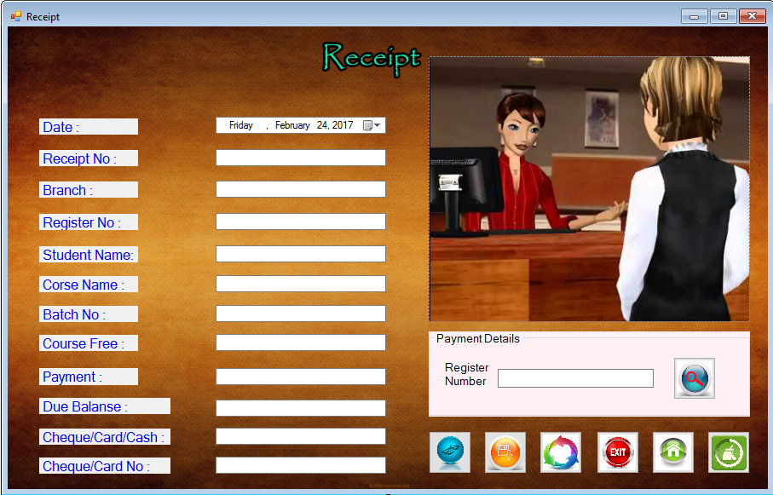

using System;

using System.Collections.Generic;

using System.ComponentModel;

using System.Data;

using System.Drawing;

using System.Linq;

using System.Text;

using System.Threading.Tasks;

using System.Windows.Forms;

using System.Data.SqlClient;

namespace Bright_Education_Acadamy_in_Sri_Lanka

{

public partial class Cashier_Receipt : Form

{

public Cashier_Receipt()

{

InitializeComponent();

}

SqlConnection con = new SqlConnection(@"Data Source = (LocalDB)\MSSQLLocalDB; AttachDbFilename=C:\Users\User\Documents\Visual Studio 2015\Projects\Bright Education Acadamy in Sri Lanka\Bright Education Acadamy in Sri Lanka\DB.mdf;Integrated Security = True");

private void btnSa_Click(object sender, EventArgs e)

{

try

{

int Re = int.Parse(textBox2.Text);

String Br = textBox3.Text;

int Reg = int.Parse(textBox4.Text);

String St = textBox5.Text;

String Co = textBox6.Text;

int Ba = int.Parse(textBox7.Text);

int Cou = int.Parse(textBox8.Text);

int Pa = int.Parse(textBox9.Text);

int Du = int.Parse(textBox12.Text);

String query_insert = "INSERT INTO Bill VALUES('" + Re + "','" + Br + "','" + Reg + "','" + St + "','" + Co + "','" + Ba + "','" + Cou + "','" + Pa + "','" + Du + "')";

SqlCommand cmnd = new SqlCommand(query_insert, con);

con.Open();

cmnd.ExecuteNonQuery();

MessageBox.Show("Saved Successfully!");

}

catch (SqlException ex)

{

MessageBox.Show("Error whiling saving" + ex);

}

finally

{

con.Close();

}

}

private void btncalculator_Click(object sender, EventArgs e)

{

int V2, V3, T;

V2 = int.Parse(textBox8.Text);

V3 = int.Parse(textBox9.Text);

T = V2 - V3;

textBox12.Text = T.ToString();

}

private void btnExit_Click(object sender, EventArgs e)

{

DialogResult Dialog = MessageBox.Show("Do you really want to Exit From The program ?", "Exit", MessageBoxButtons.YesNo);

if (Dialog == DialogResult.Yes)

{

Application.Exit();

}

else if (Dialog == DialogResult.No)

{

}

}

private void btnHome_Click(object sender, EventArgs e)

{

timer1.Enabled = true;

timer1.Start();

}

private void btnClear_Click(object sender, EventArgs e)

{

textBox2.Clear();

textBox3.Clear();

textBox4.Clear();

textBox5.Clear();

textBox6.Clear();

textBox7.Clear();

textBox8.Clear();

textBox9.Clear();

textBox10.Clear();

textBox11.Clear();

textBox12.Clear();

}

private void timer1_Tick(object sender, EventArgs e)

{

this.Opacity -= 0.10;

if (this.Opacity <= 0)

{

this.Visible = false;

timer1.Enabled = false;

new Main_Menu().Show();

}

}

private void button3_Click(object sender, EventArgs e)

{

try

{

string Re = txtRe.Text;

string query_serch = "SELECT * FROM Bill WHERE Register_No= '" + Re + "'";

SqlCommand cmnd = new SqlCommand(query_serch, con);

con.Open();

SqlDataReader r = cmnd.ExecuteReader();

while (r.Read())

{

textBox2.Text = r[0].ToString();

textBox3.Text = r[1].ToString();

textBox4.Text = r[2].ToString();

textBox5.Text = r[3].ToString();

textBox6.Text = r[4].ToString();

textBox7.Text = r[5].ToString();

textBox8.Text = r[6].ToString();

textBox9.Text = r[7].ToString();

textBox12.Text = r[8].ToString();

}

}

catch (SqlException ex)

{

MessageBox.Show("Error while Searching" + ex);

}

finally

{

con.Close();

}

}

private void button2_Click(object sender, EventArgs e)

{

try

{

int Re = int.Parse(textBox2.Text);

String Br = textBox3.Text;

int Reg = int.Parse(textBox4.Text);

String St = textBox5.Text;

String Co = textBox6.Text;

int Ba = int.Parse(textBox7.Text);

int Cou = int.Parse(textBox8.Text);

int Pa = int.Parse(textBox9.Text);

int Du = int.Parse(textBox12.Text);

string updatesql = "update Bill set Receipt_No ='" + Re + "',Branch ='" + Br + "', Register_No ='" + Reg + "',Student_Name ='" + St + "',Course_Name ='" +Co + "',Batch_No ='" + Ba + "',Course_Fee ='" + Cou + "',Payment ='" +Pa + "',Due_Balanse ='" + Du + "'";

SqlCommand cmnd = new SqlCommand(updatesql, con);

con.Open();

cmnd.ExecuteNonQuery();

MessageBox.Show("Update Successfully !");

}

catch (SqlException ex)

{

MessageBox.Show("Error while Updating" + ex);

}

finally

{

con.Close();

}

}

}

}

15. Education Details page

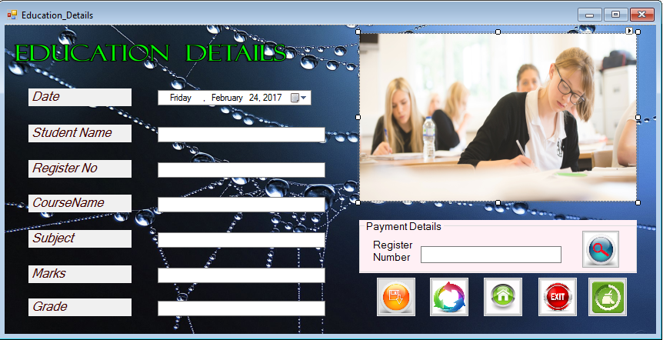

using System;

using System.Collections.Generic;

using System.ComponentModel;

using System.Data;

using System.Drawing;

using System.Linq;

using System.Text;

using System.Threading.Tasks;

using System.Windows.Forms;

using System.Data.SqlClient;

namespace Bright_Education_Acadamy_in_Sri_Lanka

{

public partial class Education_Details : Form

{

public Education_Details()

{

InitializeComponent();

}

SqlConnection con = new SqlConnection(@"Data Source = (LocalDB)\MSSQLLocalDB; AttachDbFilename=C:\Users\User\Documents\Visual Studio 2015\Projects\Bright Education Acadamy in Sri Lanka\Bright Education Acadamy in Sri Lanka\DB.mdf;Integrated Security = True");

private void timer1_Tick(object sender, EventArgs e)

{

// this.Opacity += 0.01;

//if (this.Opacity >= 0.98)

{

// timer1.Enabled = false;

}

}

private void timer2_Tick(object sender, EventArgs e)

{

this.Opacity -= 0.10;

if (this.Opacity <= 0)

{

this.Visible = false;

timer2.Enabled = false;

new Main_Menu().Show();

}

}

private void btnClear_Click(object sender, EventArgs e)

{

txtGrade.Clear();

txtSubject.Clear();

txtMarks.Clear();

txtCourseName.Clear(); ;

txtRegisterNo.Clear();

txtName.Clear();

}

private void btnSa_Click(object sender, EventArgs e)

{

try

{

String query_insert = "INSERT INTO Education_Details VALUES('" + dateTimePicker1.Value + "','" + txtName.Text + "','" + txtRegisterNo.Text + "','" + txtCourseName.Text + "','" + txtSubject.Text + "','" + txtMarks.Text + "','" + txtGrade.Text + "')";

SqlCommand cmnd = new SqlCommand(query_insert, con);

con.Open();

cmnd.ExecuteNonQuery();

MessageBox.Show("Saved Successfully!");

}

catch (SqlException ex)

{

MessageBox.Show("Error whiling saving" + ex);

}

finally

{

con.Close();

}

}

private void button2_Click(object sender, EventArgs e)

{

try

{

int Re = int.Parse(txtRegisterNo.Text);

int Ma = int.Parse(txtMarks.Text);

string updatesql = "update Education_Details set Student_Name ='" + txtName.Text + "', Register_No ='" + Re + "', Course_Name ='" + txtCourseName.Text + "', Subject ='" + txtSubject.Text + "', Marks ='" + Ma + "', Grade ='" + txtGrade.Text + "'";

SqlCommand cmnd = new SqlCommand(updatesql, con);

con.Open();

cmnd.ExecuteNonQuery();

MessageBox.Show("Update Successfully !");

}

catch (SqlException ex)

{

MessageBox.Show("Error while Updating" + ex);

}

finally

{

con.Close();

}

}

private void Education_Details_Load(object sender, EventArgs e)

{

this.MaximumSize = this.MinimumSize = this.Size;

this.MaximizeBox = false;

}

private void button3_Click(object sender, EventArgs e)

{

try

{

String pd = dateTimePicker1.Value.ToString("dd/mm/yyyy");

String Re = txtRe.Text;

string query_serch = "SELECT * FROM Education_Details WHERE Register_No= '" + Re + "'";

SqlCommand cmnd = new SqlCommand(query_serch, con);

con.Open();

SqlDataReader r = cmnd.ExecuteReader();

while (r.Read())

{

pd = r[0].ToString();

txtName.Text = r[1].ToString();

txtRegisterNo.Text = r[2].ToString();

txtCourseName.Text = r[3].ToString();

txtSubject.Text = r[4].ToString();

txtMarks.Text = r[5].ToString();

txtGrade.Text = r[6].ToString();

}

}

catch (SqlException ex)

{

MessageBox.Show("Error while Searching" + ex);

}

finally

{

con.Close();

}

}

private void btnMain_Menu_Click(object sender, EventArgs e)

{

timer2.Enabled = true;

timer2.Start();

}

private void btnExit_Click_1(object sender, EventArgs e)

{

DialogResult Dialog = MessageBox.Show("Do you really want to Exit From The program ?", "Exit", MessageBoxButtons.YesNo);

if (Dialog == DialogResult.Yes)

{

Application.Exit();

}

else if (Dialog == DialogResult.No)

{

}

}

}

}

16. Student Register page

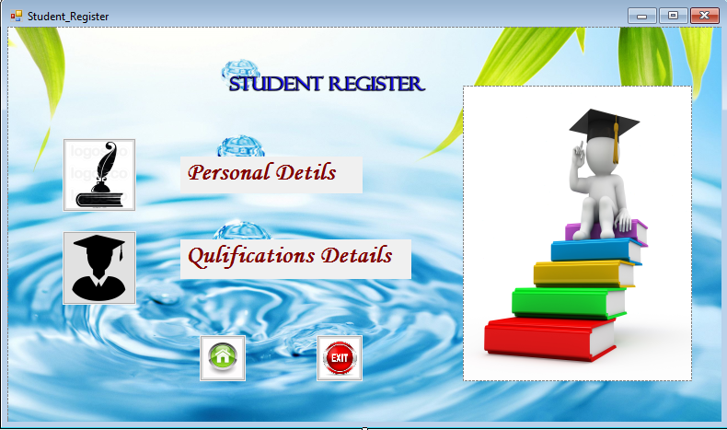

using System;

using System.Collections.Generic;

using System.ComponentModel;

using System.Data;

using System.Drawing;

using System.Linq;

using System.Text;

using System.Threading.Tasks;

using System.Windows.Forms;

namespace Bright_Education_Acadamy_in_Sri_Lanka

{

public partial class Student_Register : Form

{

public Student_Register()

{

InitializeComponent();

}

private void timer1_Tick(object sender, EventArgs e)

{

this.Opacity -= 0.10;

if (this.Opacity <= 0)

{

this.Visible = false;

timer1.Enabled = false;

new Personal_Details().Show();

}

}

private void timer2_Tick(object sender, EventArgs e)

{

this.Opacity -= 0.10;

if (this.Opacity <= 0)

{

this.Visible = false;

timer2.Enabled = false;

new Qualifications_Details().Show();

}

}

private void timer5_Tick(object sender, EventArgs e)

{

this.Opacity -= 0.10;

if (this.Opacity <= 0)

{

this.Visible = false;

timer5.Enabled = false;

new Main_Menu().Show();

}

}

private void btnPe_Click(object sender, EventArgs e)

{

timer1.Enabled = true;

timer1.Start();

}

private void btnQu_Click(object sender, EventArgs e)

{

timer2.Enabled = true;

timer2.Start();

}

private void btnMain_Menu_Click(object sender, EventArgs e)

{

timer5.Enabled = true;

timer5.Start();

}

private void btnExit_Click(object sender, EventArgs e)

{

DialogResult Dialog = MessageBox.Show(" Do you really want to Exit From The program ?", "Exit", MessageBoxButtons.YesNo);

if (Dialog == DialogResult.Yes)

{

Application.Exit();

}

else if (Dialog == DialogResult.No)

{

}

}

private void Student_Register_Load(object sender, EventArgs e)

{

this.MaximumSize = this.MinimumSize = this.Size;

this.MaximizeBox = false;

}

}

}

17. Personal Details Page

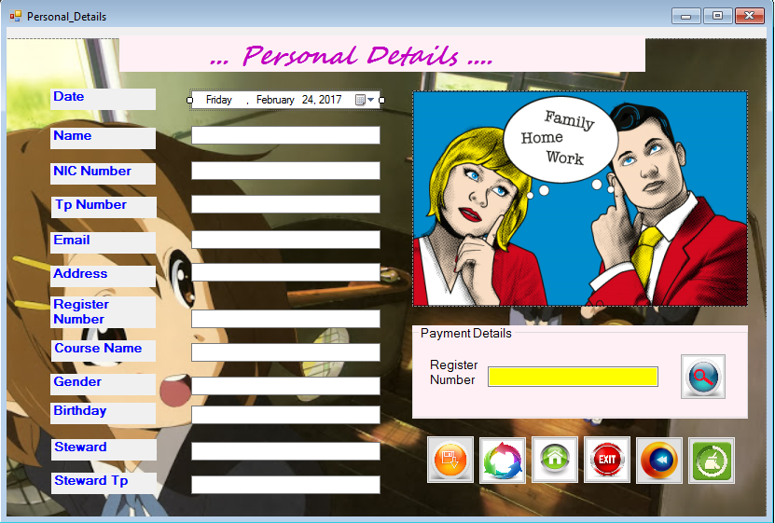

using System;

using System.Collections.Generic;

using System.ComponentModel;

using System.Data;

using System.Drawing;

using System.Linq;

using System.Text;

using System.Threading.Tasks;

using System.Windows.Forms;

using System.Data.SqlClient;

namespace Bright_Education_Acadamy_in_Sri_Lanka

{

public partial class Personal_Details : Form

{

public Personal_Details()

{

InitializeComponent();

}

SqlConnection con = new SqlConnection(@"Data Source = (LocalDB)\MSSQLLocalDB; AttachDbFilename=C:\Users\User\Documents\Visual Studio 2015\Projects\Bright Education Acadamy in Sri Lanka\Bright Education Acadamy in Sri Lanka\DB.mdf;Integrated Security = True");

private void button1_Click(object sender, EventArgs e)

{

timer1.Enabled = true;

timer1.Start();

}

private void button2_Click(object sender, EventArgs e)

{

DialogResult Dialog = MessageBox.Show(" Do you really want to Exit From The program ?", "Exit", MessageBoxButtons.YesNo);

if (Dialog == DialogResult.Yes)

{

Application.Exit();

}

else if (Dialog == DialogResult.No)

{

}

}

private void button3_Click(object sender, EventArgs e)

{

timer2.Enabled = true;

timer2.Start();

}

private void btnClear_Click(object sender, EventArgs e)

{

textBox2.Clear();

textBox3.Clear();

textBox4.Clear();

textBox5.Clear();

textBox6.Clear();

textBox7.Clear();

textBox8.Clear();

textBox9.Clear();

textBox10.Clear();

textBox11.Clear();

}

private void btnSa_Click(object sender, EventArgs e)

{

try

{

String query_insert = "INSERT INTO Personal_Details VALUES('" + dateTimePicker1.Value + "','" + textBox2.Text + "','" + textBox3.Text + "','" + textBox4.Text + "','" + textBox5.Text + "','" + textBox6.Text + "','" + textBox7.Text + "','" + textBox8.Text + "','" + textBox9.Text + "','" + textBox10.Text + "','" + textBox11.Text + "','" + textBox12.Text + "')";

SqlCommand cmnd = new SqlCommand(query_insert, con);

con.Open();

cmnd.ExecuteNonQuery();

MessageBox.Show("Saved Successfully!");

}

catch (SqlException ex)

{

MessageBox.Show("Error whiling saving" + ex);

}

finally

{

con.Close();

}

}

private void timer1_Tick(object sender, EventArgs e)

{

this.Opacity -= 0.10;

if (this.Opacity <= 0)

{

this.Visible = false;

timer1.Enabled = false;

new Main_Menu().Show();

}

}

private void timer2_Tick(object sender, EventArgs e)

{

this.Opacity -= 0.10;

if (this.Opacity <= 0)

{

this.Visible = false;

timer2.Enabled = false;

new Student_Register().Show();

}

}

private void button4_Click(object sender, EventArgs e)

{

try

{

int Tp = int.Parse(textBox4.Text);

int Re = int.Parse(textBox7.Text);

int St = int.Parse(textBox12.Text);

string updatesql = "update Personal_Details set Name ='" + textBox2.Text + "', NIC_Number ='" + textBox3.Text + "', Tp_Number ='" + Tp + "', Email ='" + textBox5.Text + "',Address ='" + textBox6.Text + "',Register_No ='" + Re + "', Course_Name ='" + textBox8.Text + "', Gender ='" + textBox9.Text + "', Birthday ='" + textBox10.Text + "', Steward ='" + textBox11.Text + "', Steward_Tp ='" + St + "'";

SqlCommand cmnd = new SqlCommand(updatesql, con);

con.Open();

cmnd.ExecuteNonQuery();

MessageBox.Show("Update Successfully !");

}

catch (SqlException ex)

{

MessageBox.Show("Error while Updating" + ex);

}

finally

{

con.Close();

}

}

private void button5_Click(object sender, EventArgs e)

{

try

{

String pd = dateTimePicker1.Value.ToString("dd/mm/yyyy");

String Re = txtRe.Text;

string query_serch = "SELECT * FROM Personal_Details WHERE Register_No= '" + Re + "'";

SqlCommand cmnd = new SqlCommand(query_serch, con);

con.Open();

SqlDataReader r = cmnd.ExecuteReader();

while (r.Read())

{

pd = r[0].ToString();

textBox2.Text = r[1].ToString();

textBox3.Text = r[2].ToString();

textBox4.Text = r[3].ToString();

textBox5.Text = r[4].ToString();

textBox6.Text = r[5].ToString();

textBox7.Text = r[6].ToString();

textBox8.Text = r[7].ToString();

textBox9.Text = r[8].ToString();

textBox10.Text = r[9].ToString();

textBox11.Text = r[10].ToString();

textBox12.Text = r[11].ToString();

}

}

catch (SqlException ex)

{

MessageBox.Show("Error while Searching" + ex);

}

finally

{

con.Close();

}

}

}

}

18. Qualifications Details page

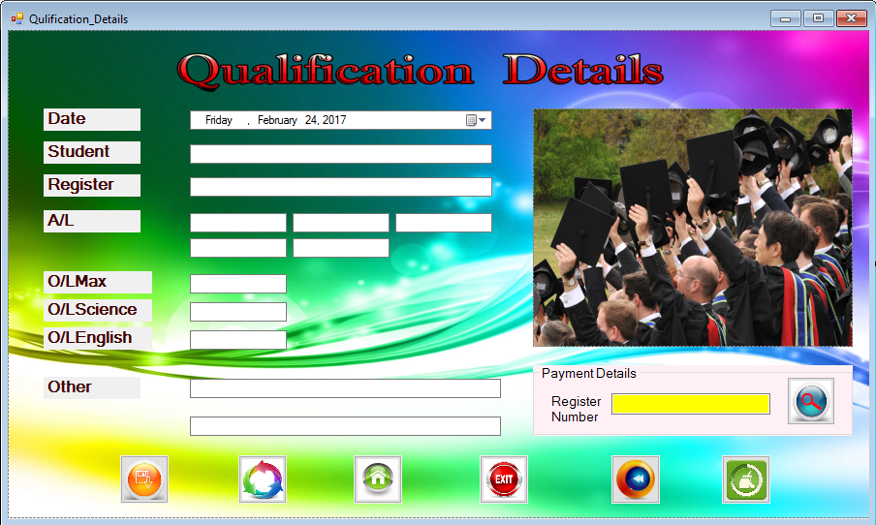

using System;

using System.Collections.Generic;

using System.ComponentModel;

using System.Data;

using System.Drawing;

using System.Linq;

using System.Text;

using System.Threading.Tasks;

using System.Windows.Forms;

using System.Data.SqlClient;

namespace Bright_Education_Acadamy_in_Sri_Lanka

{

public partial class Qualifications_Details : Form

{

public Qualifications_Details()

{

InitializeComponent();

}

SqlConnection con = new SqlConnection(@"Data Source = (LocalDB)\MSSQLLocalDB; AttachDbFilename=C:\Users\User\Documents\Visual Studio 2015\Projects\Bright Education Acadamy in Sri Lanka\Bright Education Acadamy in Sri Lanka\DB.mdf;Integrated Security = True");

private void btnSa_Click(object sender, EventArgs e)

{

try

{

String query_insert = "INSERT INTO Qualification VALUES('" + dateTimePicker1.Value + "','" + txtName.Text + "','" + txtRegisterNo.Text + "','" + txtAl1.Text + "','" + txtAl2.Text + "','" + txtAl3.Text + "','" + txtAl4.Text +"','" + txtAl5.Text + "','" + txtOlMx.Text + "','" + txtOlSc.Text + "','" + txtOlEn.Text + "','" + txtOther1.Text + "','" + txtOther2.Text + "')";

SqlCommand cmnd = new SqlCommand(query_insert, con);

con.Open();

cmnd.ExecuteNonQuery();

MessageBox.Show("Saved Successfully!");

}

catch (SqlException ex)

{

MessageBox.Show("Error whiling saving" + ex);

}

finally

{

con.Close();

}

}

private void button1_Click(object sender, EventArgs e)

{

timer1.Enabled = true;

timer1.Start();

}

private void button2_Click(object sender, EventArgs e)

{

DialogResult Dialog = MessageBox.Show(" Do you really want to Exit From The program ?", "Exit", MessageBoxButtons.YesNo);

if (Dialog == DialogResult.Yes)

{

Application.Exit();

}

else if (Dialog == DialogResult.No)

{

}

}

private void button3_Click(object sender, EventArgs e)

{

timer2.Enabled = true;

timer2.Start();

}

private void btnClear_Click(object sender, EventArgs e)

{

txtName.Clear();

txtRegisterNo.Clear();

txtAl1.Clear();

txtAl2.Clear();

txtAl3.Clear();

txtAl4.Clear();

txtAl5.Clear();

txtOlMx.Clear();

txtOlSc.Clear();

txtOlEn.Clear();

txtOther1.Clear();

txtOther2.Clear();

}

private void timer1_Tick(object sender, EventArgs e)

{

this.Opacity -= 0.10;

if (this.Opacity <= 0)

{

this.Visible = false;

timer1.Enabled = false;

new Main_Menu().Show();

}

}

private void timer2_Tick(object sender, EventArgs e)

{

this.Opacity -= 0.10;

if (this.Opacity <= 0)

{

this.Visible = false;

timer2.Enabled = false;

new Student_Register().Show();

}

}

private void button5_Click(object sender, EventArgs e)

{

try

{

String pd = dateTimePicker1.Value.ToString("dd/mm/yyyy");

String Re = txtRe.Text;

string query_serch = "SELECT * FROM Qualification WHERE Register_No= '" + Re + "'";

SqlCommand cmnd = new SqlCommand(query_serch, con);

con.Open();

SqlDataReader r = cmnd.ExecuteReader();

while (r.Read())

{

pd = r[0].ToString();

txtName.Text = r[1].ToString();

txtRegisterNo.Text = r[2].ToString();

txtAl1.Text = r[3].ToString();

txtAl2.Text = r[4].ToString();

txtAl3.Text = r[5].ToString();

txtAl4.Text = r[6].ToString();

txtAl5.Text = r[7].ToString();

txtOlMx.Text = r[8].ToString();

txtOlSc.Text = r[9].ToString();

txtOlEn.Text = r[10].ToString();

txtOther1.Text = r[11].ToString();

txtOther2.Text = r[12].ToString();

}

}

catch (SqlException ex)

{

MessageBox.Show("Error while Searching" + ex);

}

finally

{

con.Close();

}

}

private void button4_Click(object sender, EventArgs e)

{

try

{

int Re = int.Parse(txtRegisterNo.Text);

string updatesql = "update Qualification set Name ='" + txtName.Text + "', Register_No ='" + Re + "', AL_Subject1 ='" + txtAl1.Text + "', AL_Subject2 ='" + txtAl2.Text + "', AL_Subject3 ='" + txtAl3.Text + "', AL_Subject4 ='" + txtAl4.Text + "', AL_Subject5 ='" + txtAl5.Text + "', oL_Max ='" + txtOlMx.Text + "', oL_Science ='" + txtOlSc.Text + "', oL_English ='" + txtOlEn.Text + "', Other1 ='" + txtOther1.Text + "', Other2 ='" + txtOther2.Text + "'";

SqlCommand cmnd = new SqlCommand(updatesql, con);

con.Open();

cmnd.ExecuteNonQuery();

MessageBox.Show("Update Successfully !");

}

catch (SqlException ex)

{

MessageBox.Show("Error while Updating" + ex);

}

finally

{

con.Close();

}

}

}

}

19. About

using System;

using System.Collections.Generic;

using System.ComponentModel;

using System.Data;

using System.Drawing;

using System.Linq;

using System.Text;

using System.Threading.Tasks;

using System.Windows.Forms;

namespace Bright_Education_Acadamy_in_Sri_Lanka

{

public partial class About : Form

{

public About()

{

InitializeComponent();

}

private void timer2_Tick(object sender, EventArgs e)

{

this.Opacity -= 0.10;

if (this.Opacity <= 0)

{

this.Visible = false;

timer2.Enabled = false;

new Software_Program().Show();

}

}

private void timer3_Tick(object sender, EventArgs e)

{

this.Opacity -= 0.10;

if (this.Opacity <= 0)

{

this.Visible = false;

timer3.Enabled = false;

new Degree_Programs().Show();

}

}

private void timer4_Tick(object sender, EventArgs e)

{

this.Opacity -= 0.10;

if (this.Opacity <= 0)

{

this.Visible = false;

timer4.Enabled = false;

new User_Main_Menu().Show();

}

}

private void btnDegreeProgram_Click(object sender, EventArgs e)

{

timer3.Enabled = true;

timer3.Start();

}

private void btnMainmenu_Click(object sender, EventArgs e)

{

timer4.Enabled = true;

timer4.Start();

}

private void btnExit_Click(object sender, EventArgs e)

{

DialogResult Dialog = MessageBox.Show(" Do you really want to Exit From The program ?", "Exit", MessageBoxButtons.YesNo);

if (Dialog == DialogResult.Yes)

{

Application.Exit();

}

else if (Dialog == DialogResult.No)

{

}

}

private void About_Load(object sender, EventArgs e)

{

this.MaximumSize = this.MinimumSize = this.Size;

this.MaximizeBox = false;

}

private void btnSoftwareProgram_Click_1(object sender, EventArgs e)

{

timer2.Enabled = true;

timer2.Start();

}

}

}

20. Software Program page 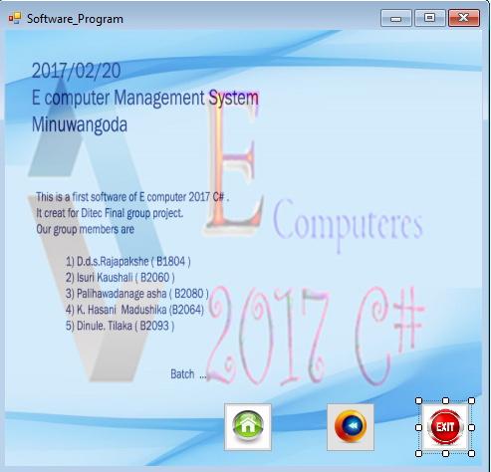

using System;

using System.Collections.Generic;

using System.ComponentModel;

using System.Data;

using System.Drawing;

using System.Linq;

using System.Text;

using System.Threading.Tasks;

using System.Windows.Forms;

namespace Bright_Education_Acadamy_in_Sri_Lanka

{

public partial class Software_Program : Form

{

public Software_Program()

{

InitializeComponent();

}

private void btnmainMenu_Click(object sender, EventArgs e)

{

timer1.Enabled = true;

timer1.Start();

}

private void btnBack_Click(object sender, EventArgs e)

{

timer2.Enabled = true;

timer2.Start();

}

private void BtnExit_Click(object sender, EventArgs e)

{

DialogResult Dialog = MessageBox.Show(" Do you really want to Exit From The program ?", "Exit", MessageBoxButtons.YesNo);

if (Dialog == DialogResult.Yes)

{

Application.Exit();

}

else if (Dialog == DialogResult.No)

{

}

}

private void timer1_Tick(object sender, EventArgs e)

{

this.Opacity -= 0.10;

if (this.Opacity <= 0)

{

this.Visible = false;

timer1.Enabled = false;

new Main_Menu().Show();

}

}

private void timer2_Tick(object sender, EventArgs e)

{

this.Opacity -= 0.10;

if (this.Opacity <= 0)

{

this.Visible = false;

timer2.Enabled = false;

new About().Show();

}

}

}

}

21. Degree Program page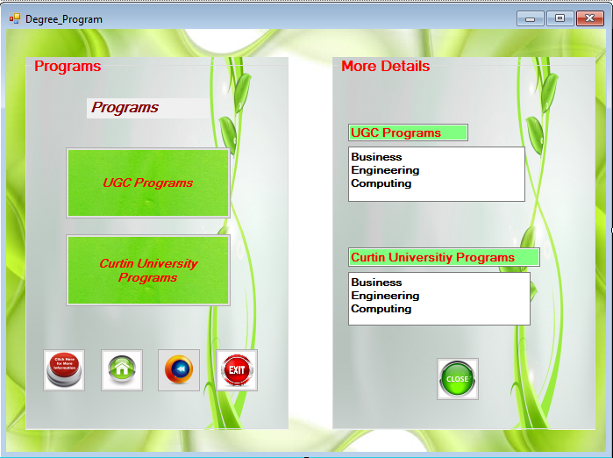

using System;

using System.Collections.Generic;

using System.ComponentModel;

using System.Data;

using System.Drawing;

using System.Linq;

using System.Text;

using System.Threading.Tasks;

using System.Windows.Forms;

namespace Bright_Education_Acadamy_in_Sri_Lanka

{

public partial class Degree_Programs : Form

{

public Degree_Programs()

{

InitializeComponent();

}

private void timer1_Tick(object sender, EventArgs e)

{

this.Opacity -= 0.10;

if (this.Opacity <= 0)

{

this.Visible = false;

timer1.Enabled = false;

new Main_Menu().Show();

}

}

private void timer2_Tick(object sender, EventArgs e)

{

this.Opacity -= 0.10;

if (this.Opacity <= 0)

{

this.Visible = false;

timer2.Enabled = false;

new About().Show();

}

}

private void timer3_Tick(object sender, EventArgs e)

{

this.Opacity -= 0.10;

if (this.Opacity <= 0)

{

this.Visible = false;

timer3.Enabled = false;

new UGC_Programs().Show();

}

}

private void timer4_Tick(object sender, EventArgs e)

{

this.Opacity -= 0.10;

if (this.Opacity <= 0)

{

this.Visible = false;

timer4.Enabled = false;

new Curtin_University_Programs().Show();

}

}

private void btnmainMenu_Click(object sender, EventArgs e)

{

timer1.Enabled = true;

timer1.Start();

}

private void btnBack_Click(object sender, EventArgs e)

{

timer2.Enabled = true;

timer2.Start();

}

private void BtnExit_Click(object sender, EventArgs e)

{

DialogResult Dialog = MessageBox.Show(" Do you really want to Exit From The program ?", "Exit", MessageBoxButtons.YesNo);

if (Dialog == DialogResult.Yes)

{

Application.Exit();

}

else if (Dialog == DialogResult.No)

{

}

}

private void button1_Click(object sender, EventArgs e)

{

this.Width = 700;

Refresh();

}

private void button3_Click(object sender, EventArgs e)

{

timer4.Enabled = true;

timer4.Start();

}

private void button2_Click(object sender, EventArgs e)

{

timer3.Enabled = true;

timer3.Start();

}

private void Degree_Programmes_Load(object sender, EventArgs e)

{

this.Width = 350;

this.MinimumSize = this.Size;

this.MaximizeBox = false;

}

private void button4_Click(object sender, EventArgs e)

{

this.Width = 350;

Refresh();

}

}

}

22. UGC Programs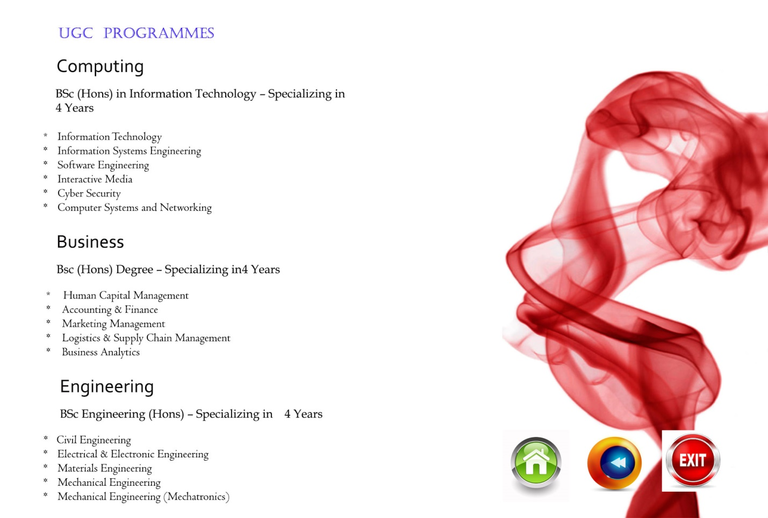

using System;

using System.Collections.Generic;

using System.ComponentModel;

using System.Data;

using System.Drawing;

using System.Linq;

using System.Text;

using System.Threading.Tasks;

using System.Windows.Forms;

namespace Bright_Education_Acadamy_in_Sri_Lanka

{

public partial class UGC_Programs : Form

{

public UGC_Programs()

{

InitializeComponent();

}

private void timer1_Tick(object sender, EventArgs e)

{

this.Opacity -= 0.10;

if (this.Opacity <= 0)

{

this.Visible = false;

timer1.Enabled = false;

new User_Main_Menu().Show();

}

}

private void timer2_Tick(object sender, EventArgs e)

{

this.Opacity -= 0.10;

if (this.Opacity <= 0)

{

this.Visible = false;

timer2.Enabled = false;

new Degree_Programs().Show();

}

}

private void btnmainMenu_Click(object sender, EventArgs e)

{

timer1.Enabled = true;

timer1.Start();

}

private void btnBack_Click(object sender, EventArgs e)

{

timer2.Enabled = true;

timer2.Start();

}

private void BtnExit_Click(object sender, EventArgs e)

{

DialogResult Dialog = MessageBox.Show(" Do you really want to Exit From The program ?", "Exit", MessageBoxButtons.YesNo);

if (Dialog == DialogResult.Yes)

{

Application.Exit();

}

else if (Dialog == DialogResult.No)

{

}

}

}

}

23.Curtin University Programs

using System;

using System.Collections.Generic;

using System.ComponentModel;

using System.Data;

using System.Drawing;

using System.Linq;

using System.Text;

using System.Threading.Tasks;

using System.Windows.Forms;

namespace Bright_Education_Acadamy_in_Sri_Lanka

{

public partial class Curtin_University_Programs : Form

{

public Curtin_University_Programs()

{

InitializeComponent();

}

private void btnmainMenu_Click(object sender, EventArgs e)

{

timer1.Enabled = true;

timer1.Start();

}

private void btnBack_Click(object sender, EventArgs e)

{

timer2.Enabled = true;

timer2.Start();

}

private void BtnExit_Click(object sender, EventArgs e)

{

DialogResult Dialog = MessageBox.Show(" Do you really want to Exit From The program ?", "Exit", MessageBoxButtons.YesNo);

if (Dialog == DialogResult.Yes)

{

Application.Exit();

}

else if (Dialog == DialogResult.No)

{

}

}

private void timer1_Tick(object sender, EventArgs e)

{

this.Opacity -= 0.10;

if (this.Opacity <= 0)

{

this.Visible = false;

timer1.Enabled = false;

new Main_Menu().Show();

}

}

private void timer2_Tick(object sender, EventArgs e)

{

this.Opacity -= 0.10;

if (this.Opacity <= 0)

{

this.Visible = false;

timer2.Enabled = false;

new Degree_Programs().Show();

}

}

}

}

1. Help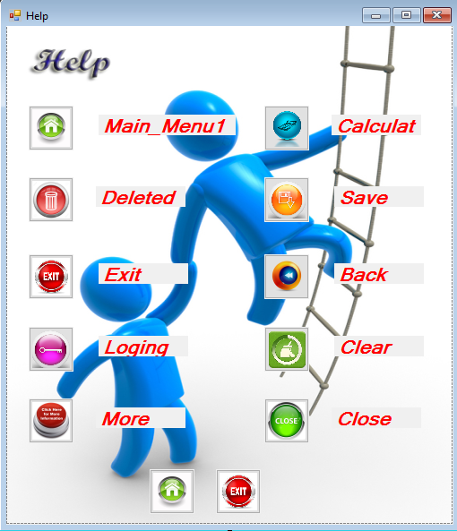

using System;

using System.Collections.Generic;

using System.ComponentModel;

using System.Data;

using System.Drawing;

using System.Linq;

using System.Text;

using System.Threading.Tasks;

using System.Windows.Forms;

namespace Bright_Education_Acadamy_in_Sri_Lanka

{

public partial class Help : Form

{

public Help()

{

InitializeComponent();

}

private void timer1_Tick(object sender, EventArgs e)

{

// this.Opacity += 0.01;

//if (this.Opacity >= 0.98)

{

// timer1.Enabled = false;

}

}

private void timer2_Tick(object sender, EventArgs e)

{

this.Opacity -= 0.10;

if (this.Opacity <= 0)

{

this.Visible = false;

timer2.Enabled = false;

new Main_Menu().Show();

}

}

private void btnMainmenu_Click(object sender, EventArgs e)

{

timer2.Enabled = true;

timer2.Start();

}

private void btnExit_Click(object sender, EventArgs e)

{

DialogResult Dialog = MessageBox.Show(" Do you really want to Exit From The program ?", "Exit", MessageBoxButtons.YesNo);

if (Dialog == DialogResult.Yes)

{

Application.Exit();

}

else if (Dialog == DialogResult.No)

{

}

}

private void Help_Load(object sender, EventArgs e)

{

this.MaximumSize = this.MinimumSize = this.Size;

this.MaximizeBox = false;

}

}

}

25. Student Registration System USE Case

View Qualification

**User**

**System**

**Cashier Receipt**

**Education Detail**

**Personal Detail**

**Admin**

**Detail Student**

View Education

View Payment

View Personal

